

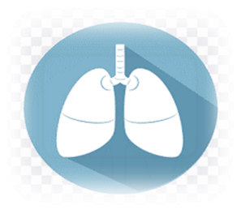
Capstone portfolio
Group (23328)
G12 semester (1)
Asthma Guide



Names | ID | E-mail | Rule
Nour Mursy | 2321545 | Nour.2321545@stemqena.moe.edu.eg | Writer
Nadia Adel | 2321542 | nadia.2321542@stemqena.moe.edu.eg | Presenter
Gehan Mahmoud | 2321512 | gehan.2321512@stemqena.moe.edu.eg | Leader

Table of Contents:
- Introduction (4)
- Egypt Grand and Challenges (5 to 6)
- Problem to be solved (6 to 8)
- Research (9)
- Other solution already tried (10 to 16)
- Solution and Design Requirements (16)
- Selection of Solution (17 to 18)
- Selection Prototype (18)
- Materials Methods (19 to 20)
- Test Plan (20)
- Data Collection (21 to 23)
- Analysis and Discussion (23 to 26)
- Recommendations (26 to 27)
- Learning Outcomes (27 to 32)

Introduction
Egypt faces many issues that have a detrimental effect on the country's social life, economy, ecology, and health; these issues stand in the way of Egypt's advancement, growth, and prosperity. Among the difficulties facing our nation are expanding Egypt's industrial base and eradicating public health problems and diseases. But the elimination of public health difficulties and diseases is one of the most pressing challenges that has a definite detrimental effect and given rise to numerous major issues. The increase in percent of people affected with chronic diseases is because of negligence in eradicate public health issues Many projects and prior solutions have been applied to overcome this problem such as: The Butterfly iQ which is a handheld ultrasound device that utilizes AI technology to aid in the diagnosis and monitoring of various medical conditions, Aidoc is a radiology platform that utilizes AI technology to assist in the detection and prioritization of critical findings in medical imaging studies, It aims to enhance the efficiency and accuracy of radiologists and Google DeepMind's Streams is an AI-powered platform designed to assist clinicians in monitoring and managing patients with acute kidney injury (AKI). In addition to the challenges that Egypt faces, there are also specific health issues that require urgent attention. Asthma is one of these problems; it is a chronic respiratory condition that affects millions of individuals globally. Due to its high rates of death and prevalence, asthma is a serious public health concern in Egypt. Recent data indicates that 15% of Egyptians have asthma, and that the country has one of the highest asthma-related death rates worldwide. Contributing to the improvement of asthma sufferers' lives by developing a hardware system that works with a mobile application software system. Since various persons are impacted by various circumstances, our system's application depends on three variables: temperature, humidity, and smoke. Thus, the design specifications that we shall address measuring the environment's temperature and humidity, measuring CO2 levels, and testing the system's reaction time in relation to its input and processing. Patients with asthma will be able to better manage environmental influences, become more self-reliant, and learn more about their illness and management techniques which is the solution objective.

Present and Justify a Problem and Solution Requirements
- Requirements Egypt Grand Challenge(s):

1-Work to eradicate public health issues/diseases:
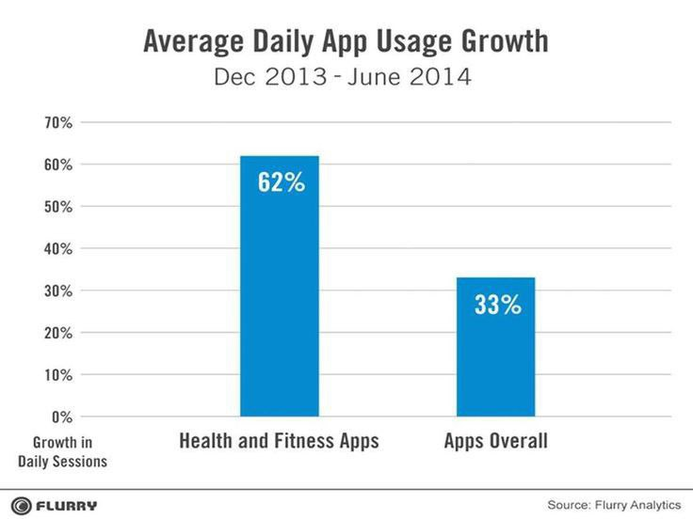
Public health is the science of protecting and improving the health of people and their communities. This work is achieved by promoting healthy lifestyles, researching disease and injury prevention, and detecting, preventing, and responding to infectious diseases. Overall, public health is concerned with protecting the health of entire population. (as you see in graph 1)
Graph (1)
Dec 2020 – June 2021
2-Increase the industrial bases of Egypt:
The industrial base refers to the infrastructure, facilities, and resources that support industrial production and economic development within a country. It includes factors such as manufacturing plants, factories, transportation networks, energy sources, and skilled labor for Egypt it represents in Tourism, Food Processing, Construction and Building Materials and Technology for sure.
Increasing and improving technology in Egypt can have several positive impacts on the industrial base and help in increasing industries bases of Egypt. Here are some ways in which technology can contribute to the growth and development of industries in Egypt:
Digitalization and Connectivity: Technology can facilitate digitalization and connectivity within industries. This includes the use of digital platforms, data analytics, and the Internet of Things (IoT) to optimize operations, improve supply chain management, and enhance communication between different stakeholders. Digitalization can also enable industries to tap into global markets and participate in e-commerce platforms.
Access to Global Markets: Technology can help in expanding the reach of Egyptian industries to global markets. By leveraging digital platforms, e-commerce channels, and online marketing strategies, industries can overcome geographical barriers and access.
wider customer base. This can lead to increased exports, foreign investment, and economic growth.
Overall, increasing technology in Egypt can significantly contribute to the growth and development of industries. It can enhance productivity, promote innovation, improve connectivity, and enable access to global markets. However, it is essential for the government and industry stakeholders to invest in infrastructure, skills development, and supportive policies to fully harness the potential of technology for industrial growth.
And this is one way we will indicate try using it for increasing industries bases for Egypt. That if it kept in declining will cause many problems will discuss in coming.
- Problem to be solved:
For Work to eradicate public health issues/diseases:
If the problem solved:

- Reduced healthcare costs: By preventing and managing diseases at an early stage, healthcare costs can be significantly reduced. This would alleviate the burden on healthcare systems and allow resources to be allocated more efficiently.

- Increased productivity: A healthier population is likely to be more productive, leading to economic growth and development. With fewer individuals suffering from illness and disability, there would be an increase in workforce participation and productivity.

- Enhanced quality of life: Improved public health would lead to a higher quality of life for individuals and communities. People would be able to live longer, healthier lives, free from the burden of preventable diseases and health issues.

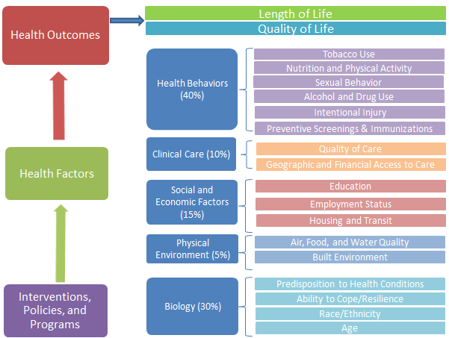
- Global health security: Effective public health measures not only benefit individual countries but also contribute to global health security. By preventing and controlling the spread of infectious diseases, countries can work together to protect populations worldwide and prevent future pandemics. (As you see in figure 1)

Fig (1)
If the problem not solved:

1. Increased incidence and prevalence of diseases: Without effective public health measures, the incidence and prevalence of infectious diseases, chronic diseases, and other health problems would likely increase. This would result in a higher burden of illness and a decrease in overall population health. (as you see in figure 2)

2. Higher healthcare costs: The lack of prevention and early intervention measures would lead to higher healthcare costs. More individuals would require costly treatments and hospitalizations, putting a strain on healthcare systems and resources.

3. Decreased productivity: A population facing significant health challenges would likely experience decreased productivity. Illness and disability would hinder workforce participation and economic growth.

4. Lower quality of life: Without effective public health interventions, individuals would experience a lower quality of life due to preventable diseases and health issues. Life expectancy may decrease, and people may suffer from chronic conditions and disabilities.
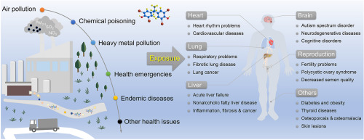

Fig (2)
For increase the industrial bases of Egypt:
If the problem solved:

1-Economic Growth: A revived and strengthened industrial base can lead to increased economic growth and development.
2-Reduced Unemployment and Poverty: With a growing industrial base, there will be more job opportunities available, reducing unemployment rates.
3-Retention of Skilled Workers: A revitalized industrial base can help retain skilled workers and professionals in the country.
4-Increased Self-Sufficiency: A strong industrial base will reduce dependence on imports and promote domestic production
5- Enhanced Innovation and Technological Advancements: With a thriving industrial base, there will be increased investment in research and development activities.
If the problem not solved:

If the industrial base in Egypt continues to decrease, several negative consequences can occur:
-1Economic Decline: The decrease in industrial bases can lead to a decline in economic growth and development.
-2Unemployment and Poverty: The decline in industries can lead to increased unemployment rates as job opportunities become scarce. This can result in a rise in poverty levels as individuals and families struggle to meet their basic needs.

3-Dependence on Imports: Egypt may become heavily reliant on imported goods and products.

-4Brain Drain: A decrease in industries can result in a brain drain, where skilled workers and professionals leave the country in search of better opportunities elsewhere. This can further exacerbate the skills gap and hinder the development of new industries.
- Research:
1-Asthma disease: Asthma is a chronic respiratory condition characterized by inflammation and narrowing of the airways, leading to symptoms such as wheezing, shortness of breath, coughing, and chest tightness.
2- AI forms: AI forms refer to artificial intelligence-based systems or software that are designed to create, process, or analyze digital forms, such as surveys, questionnaires, or data entry forms, using advanced machine learning algorithms and natural language processing techniques.
3- Firebase in programming: Firebase is a mobile and web application development platform developed by Google. It provides a variety of tools and services for building and managing applications, including features such as real-time database, authentication, cloud messaging, and hosting.
4- ESP: ESP stands for "electronic stability program" or "electronic stability control," which is a computerized technology.
5- URL in ESP: In the context of ESP (especially in relation to IoT devices like the ESP8266 or ESP32), a URL (Uniform Resource Locator) refers to the address of a specific resource on the internet that the device can access, such as a web page, image, or data file.
6- .URL: In the context of programming or file systems, .URL is a file extension used to denote a shortcut or bookmark file that contains the address of a specific resource (such as a website or network location) and can be used to quickly access that resource.

- Prior solutions:
Introduction for first prior solution:
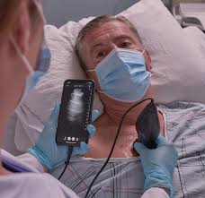
The Butterfly iQ is a handheld ultrasound device that utilizes AI technology to aid in the diagnosis and monitoring of various medical conditions. It offers a portable and accessible solution for healthcare professionals, allowing them to perform ultrasound examinations at the point of care. The device consists of a handheld probe that connects to a mobile device, enabling real-time imaging and analysis. (as you see in figure 3)
Fig (3)
strengths | Weakness
- Portability and Accessibility: The Butterfly iQ's compact design and compatibility with mobile devices make it highly portable and accessible. It allows healthcare professionals to perform ultrasound examinations in various settings, including remote or resource-limited areas.  - Versatility: The device is capable of imaging different body areas, including the heart, abdomen, and musculoskeletal system. Its ability to provide a wide range of imaging options makes it a versatile tool for diagnosing and monitoring various conditions.  - Image Quality: The Butterfly iQ is known for its high-quality imaging capabilities. The AI algorithms integrated into the device help optimize the image acquisition process and enhance the clarity of the ultrasound images. This enables healthcare professionals to obtain detailed and accurate diagnostic information. | - Limited Expertise: While the Butterfly iQ device can provide valuable imaging capabilities, it still requires skilled healthcare professionals to interpret the images and make accurate diagnoses. The device does not replace the need for expertise and experience in ultrasound interpretation.  - Learning Curve: Like any new technology, there may be a learning curve associated with using the Butterfly iQ device effectively. Healthcare professionals who are unfamiliar with the device may need time to become proficient in its operation and interpretation of the acquired images.  - Cost: The Butterfly iQ device, although more affordable than traditional ultrasound machines, still incurs a cost. This may pose a financial challenge for healthcare facilities, especially in resource-constrained setting

Overall, the Butterfly iQ device offers several strengths, including portability, versatility, and high image quality. However, it is important to recognize that it should be used by skilled healthcare professionals and may require an investment in training and equipment costs

Introduction about second prior solution:

Aidoc is a radiology platform that utilizes AI technology to assist in the detection and prioritization of critical findings in medical imaging studies. It aims to enhance the efficiency and accuracy of radiologists by leveraging AI algorithms to analyze imaging data and identify abnormalities. Aidoc focuses on detecting urgent cases, such as intracranial hemorrhages or pulmonary embolisms, enabling timely intervention and
Fig (4)
improved patient care. (as you see in figure 4)
Strengths | Weaknesses
- Enhanced Efficiency: Aidoc's AI algorithms can analyze large volumes of medical imaging data rapidly. By highlighting critical findings, the platform helps radiologists prioritize urgent cases, reducing the time required for diagnosis and enabling prompt intervention for life-threatening conditions.  - Improved Accuracy: The AI algorithms employed by Aidoc have been trained on vast datasets, allowing them to detect abnormalities with a high level of accuracy. By flagging potential abnormalities in medical images, Aidoc can help radiologists avoid overlooking critical findings and improve diagnostic accuracy.  - Workflow Integration: Aidoc seamlessly integrates into existing radiology workflows, allowing radiologists to access the platform directly from their imaging workstations. This integration ensures a smooth transition and minimizes disruptions to the radiology workflow. | - Reliance on Quality Imaging: Aidoc's effectiveness heavily relies on the quality of the medical images it analyzes. In cases where imaging quality is suboptimal or compromised, the accuracy and performance of the AI algorithms may be affected, potentially leading to false-positive or false-negative results.  - Limited Scope: Aidoc primarily focuses on the detection and prioritization of critical findings in specific areas, such as intracranial hemorrhages or pulmonary embolisms. While it provides valuable support for urgent cases, it may not cover the entire spectrum of radiological abnormalities or assist in the diagnosis of less critical conditions.  - Integration Challenges: Implementing a new technology like Aidoc into existing radiology workflows may pose integration challenges. Integration can require adjustments to the existing systems and processes, and initial setup and training may be necessary to ensure smooth adoption and effective utilization of the platform.

Overall, Aidoc offers strengths in terms of enhanced efficiency, improved accuracy, and seamless workflow integration. However, it is essential to consider the potential limitations related to image quality, the scope of detection, and the integration process when incorporating Aidoc into radiology practices.

Introduction for third prior solution:
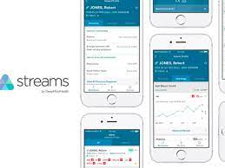
Google DeepMind's Streams is an AI-powered platform designed to assist clinicians in monitoring and managing patients with acute kidney injury (AKI). It leverages AI algorithms to provide real-time alerts, risk predictions, and clinical decision support, enabling healthcare professionals to optimize patient care. Streams aims to enhance patient outcomes by facilitating early detection and timely intervention for AKI, a condition associated with a significant risk of complications.
Fig (5)
(as you see in figure 5)

Strengths | Weaknesses
1- Real-time Alerts: Streams provides real-time alerts to clinicians, notifying them of potential AKI cases or changes in patients' kidney function. This enables healthcare professionals to promptly assess and address the condition, improving the chances of timely intervention and better patient outcomes.  2-Risk Predictions: The AI algorithms utilized in Streams can analyze patient data and generate risk predictions for AKI. By identifying patients at a higher risk of developing AKI, healthcare professionals can proactively monitor and implement preventive measures, potentially reducing the incidence and severity of the condition.  3-Clinical Decision Support: Streams offers clinical decision support tools that provide clinicians with evidence-based recommendations and guidelines for managing AKI. This assists healthcare professionals in making informed decisions about treatment options, interventions, and patient care plans. | 1-Data Integration and Interoperability: Integrating Streams into existing healthcare systems and ensuring interoperability with electronic health records (EHRs) can be a challenge. The platform's efficiency relies on seamless data integration and accessibility, which may require significant effort and coordination between different healthcare IT systems.  2-Generalizability: While Streams shows promise in assisting with AKI management, its performance may vary across different healthcare settings and patient populations. The effectiveness of the AI algorithms may depend on the availability and quality of data specific to the target patient population, potentially limiting its generalizability.  3-Ethical and Privacy Considerations: AI platforms like Streams raise concerns related to patient privacy and data security. Safeguarding patient information and ensuring compliance with data protection regulations are critical aspects that need to be addressed when implementing and utilizing such platforms.

Overall, Google DeepMind's Streams offers strengths in terms of real-time alerts, risk predictions, and clinical decision support for AKI management. However, challenges related to data integration, generalizability, and ethical considerations need to be carefully addressed to maximize its potential benefits and ensure patient privacy and safety.

Introduction for forth prior solution:
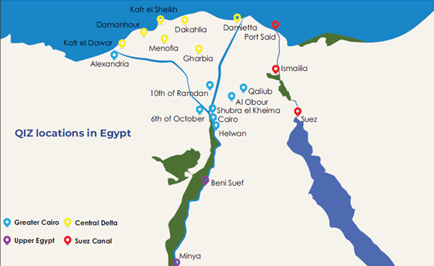
The Egyptian free zones program began in the mid-1970s with the establishment of zones in Port Said, Suez, Alexandria, and El Nasr City. The Ismailia zone was established in 1979 and Damietta in 1992. Media City was established in February 2000 (as you see in figure 6).
These zones aimed to attract both domestic and foreign investments by providing various incentives such as tax breaks, streamlined regulations, and infrastructure development.

Qualifying Industrial Zones (QIZs) fig (6)

The establishment of industrial zones and free trade zones in Egypt involved several steps. The government identified suitable locations and developed infrastructure within these zones. They introduced incentives and regulations to attract investments, actively marketed the zones, and collaborated with international organizations to attract foreign companies. The government also focused on specific industries and worked on job creation and skill development. They monitored and evaluated the performance of the zones to measure success.

Strength | Weakness
1. Attraction of Foreign Investment: The establishment of industrial zones and free trade zones helped attract foreign companies to invest in Egypt. This brought in new technologies, expertise, and capital, contributing to the growth of the industrial sector | 1-Limited Impact on Overall Industrial Base: While the establishment of industrial zones and free trade zones had positive effects within these specific areas, the overall industrial base in Egypt still faced challenges. The impact of these zones did not fully address the broader issues affecting the industrial sector as a whole.
2. Job Creation: The establishment of these zones created job opportunities for Egyptians, reducing unemployment rates and improving living standards. | 2-Lack of Diversification: The focus on attracting foreign investment in specific industries, such as textiles or automotive, limited the diversification of the industrial base
3. Infrastructure Development: The focus on developing infrastructure within these zones improved transportation, logistics, and connectivity, making it easier for industries to operate efficiently | 3-Concentration of Development: The development of industrial zones and free trade zones often led to a concentration of industrial activities in specific regions, primarily around major cities like Cairo and Alexandria.

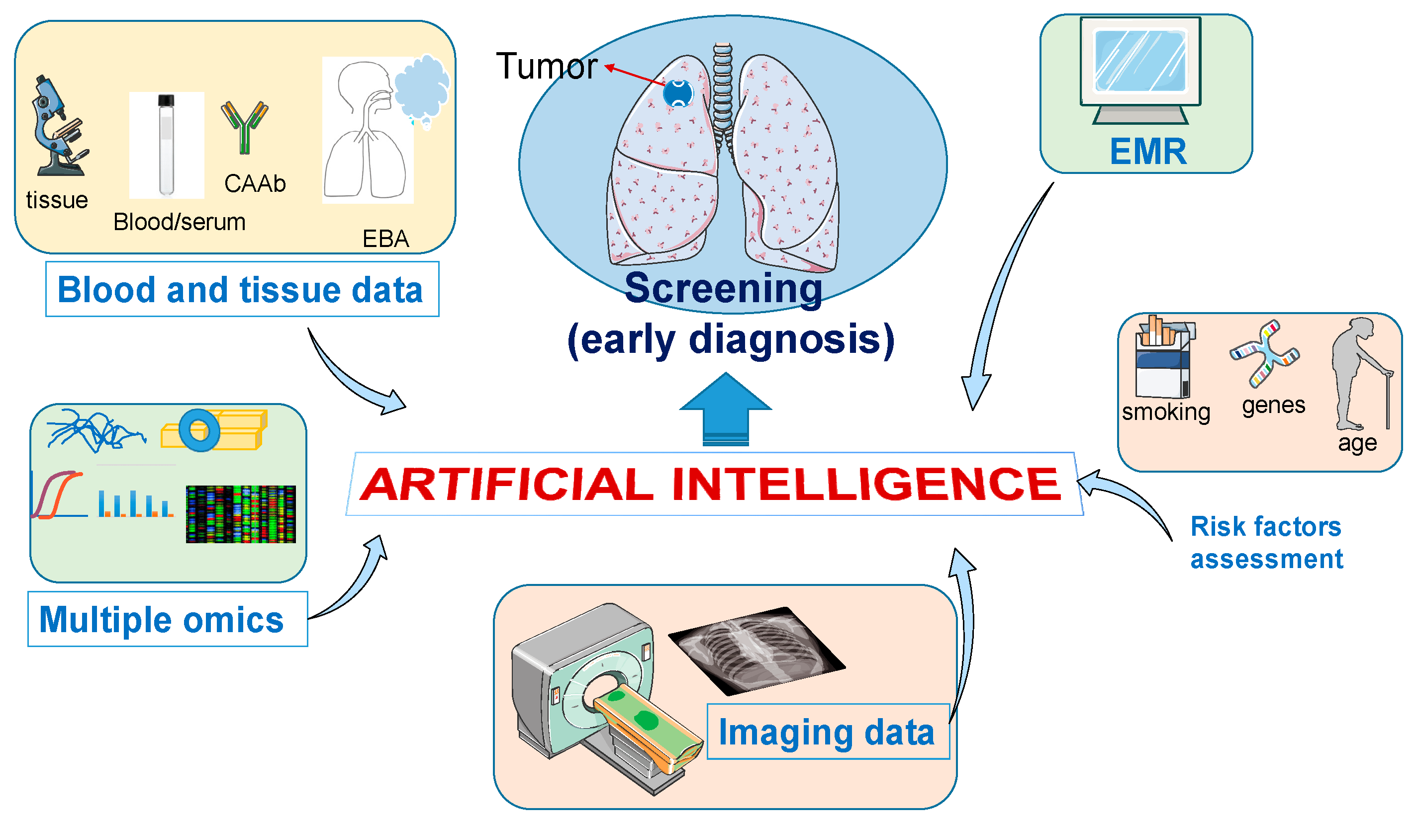
Introduction for fifth prior solution:
Early detection and diagnosis: AI has been used to develop algorithms that can analyze medical images, such as mammograms or retinal scans, to detect early signs of diseases like breast cancer or diabetic retinopathy. This can lead to earlier interventions and improved outcomes.
(As you see in figure 7)

Fig (7)

Weakness | Strength
- AI algorithms can analyze large amounts of medical images quickly and accurately, potentially detecting early signs of diseases that may be missed by human observers.  - AI can help in standardizing the interpretation of medical images, reducing variability between different healthcare professionals.  - Early detection and diagnosis through AI can lead to earlier interventions and improved outcomes for patients. | - AI algorithms can analyze large amounts of medical images quickly and accurately, potentially detecting early signs of diseases that may be missed by human observers.  - AI can help in standardizing the interpretation of medical images, reducing variability between different healthcare professionals.  - Early detection and diagnosis through AI can lead to earlier interventions and improved outcomes for patients.

Generating and Defending a Solution
- Solution and Design Requirements:
General design requirements: It is the design requirements that must be available in any project to ensure the efficiency and usability of the project, such as:
1. Safety: It is the state of not being in danger, which may be achieved by following the prototyping process's precautions. We observed the chemistry lab precautions when manufacturing the tested item, such as using gloves and the designated uniform when working with chemicals and not performing any high exothermic reactions (reactions that release heat energy) without supervision.
2. Sustainability: The projects distinguish from one another due to their ability to be sustained. The ability to progress continuously is dependent on the continuous production of green or waste materials. We were able to do so by reducing the cost of the process and ensuring a steady supply by turning waste oil into soap.
Project-specific design requirements: it is the design requirements that must be met in our project, such as:
- Sensing Temperature and humidity of environment: change in the number of temperature whether it cold or hot or both can affect asthma people so, we will sense and control the change.
- Sensing co2 gas: sense and detect the change in the gas and control it.
- Testing the system response time in accordance to the system input and processing.

- Selection of Solution
To solve any problem, we should follow effective methods to get good results. So, working on our project followed the following:
- Searching about the problem (its important step to get good solution).
- Searching about prior solutions to know ideas that applied to solve the
same problem we want to solve.
- Started building prototype, writing and connecting codes and then tested it.
- Then, modify any problem and tested it again.
We followed all of these methods to start and to complete applying our solution.
This solution is:
Sharing in facilitating life for people who suffer from asthma by creating hardware system including (MQ 135 “air quality Sensor” & DHT11 “temperature & humidity sensor” & OLED “to show data on “), this hardware connected with software system which is mobile application and the criteria for this system to work is:
As different people affected by different conditions so application in our system works on three factors: temperature, humidity and smoke. Icon for temperature including three options, these three options are for people affected by “hot only”, “cold only” and “both hot and cold” air to give them options to choose which of these options trigger them according to their health condition. If reading of sensor match to what trigger the patient, the application will send notifications to alert this patient that these environmental conditions are not suitable for him. (this will help him to be more independent). Also, OLED in hardware system is to stay informed with changes by showing reading in. In addition to adding icon in mobile applications for more information and instructions about asthma disease.
Finally, this solution will help Asthma patients to control environmental factors influence on them to be more independent and know more information about their disease and how to deal with it.

- Selection of Prototype
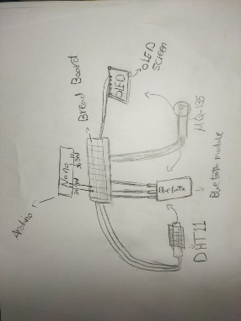
In our prototype we will solve the problems by build a simple bracelet with buttery, that when the application sends signals it will make an alert on the watch and give the reading of co2 gas and temperature on the OLED, then wristwatch structure was designed on computer and implemented in 3D printer machine and after finishing it hardware components were installed on it. Fig (8)
-After that this hardware system was connected to mobile application which includes icons to allow patient to control factors that hardware “sensors” detect.

Constructing and Testing a Prototype
- Materials and Methods:

Item | Quantity | Usage | cost | Source of purchase | Picture
DHT11 | 1 | To detect the temperature of environment | 45 pounds | Electronic shop | 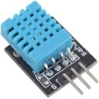
MQ135 | 1 | To detect co2 gas | 90 pounds | Electronic shop | 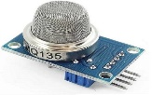
OLED SSD 1306 | 1 | To detect the reading of co2 and temp | 180 pounds | Electronic shop | 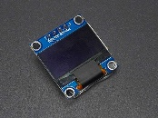
Wires | 10 | For communications | 10 pounds | Electronic shop | 
Arduino Nano | 1 | Give order to sensors | 200 pounds | Electronic shop | 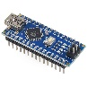
ESP8266 | 1 | Communicate with applications | 190 pounds | Electronic shop | 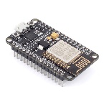
Bluetooth module | 1 | Communicate Nano with application | 195 pounds | Electronic shop | 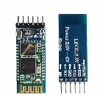

Safety:
- Personal Protective Equipment (PPE): Wear appropriate PPE, such as safety goggles, gloves, and lab coats, to protect yourself during the testing process.

- Ventilation: Ensure proper ventilation in the testing area to prevent the accumulation of potentially harmful gases or smoke. Work in a well-ventilated space or use exhaust fans or fume hoods if necessary.

- Electrical Safety: Handle electrical components and connections with caution. Ensure that all electrical connections are properly insulated and secure. Disconnect power sources before making any changes or adjustments.

- Emergency Procedures: familiar with emergency procedures, including evacuation routes, in case of any unforeseen accidents or incidents. Have emergency contact information readily available.

- Proper Wiring and Connections: Ensure that all wiring and connections are properly insulated and secured. Avoid loose or exposed wires that may pose a safety risk.

- Regular Maintenance and Inspections: Regularly inspect and maintain the testing equipment and prototype to ensure they are in good working condition. Address any issues or malfunctions promptly.

- Follow Relevant Standards and Regulations: Comply with any applicable safety standards, guidelines, or regulations specific to the testing environment or equipment being used.

Methods:
Following the inclusion of the materials required to construct the prototype, this part will detail the building process utilizing the previously specified materials.
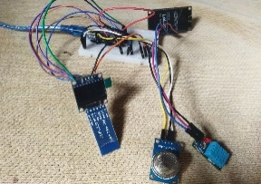
The steps used in construction of the prototype:
-First, as shown in fig. (9), the connections between the sensors (MQ135 & DHT11)
and the ESP3266, Arduino Nano board, and OLED were completed.
Fig (9)
Connecting the MQ135 sensor to an Arduino Nano to measure the
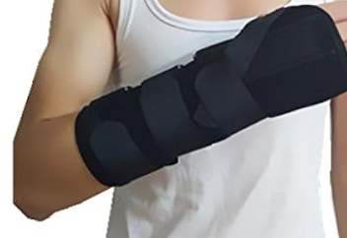
percentage of smoke and the DHT11 sensor to an ESP to measure the temperature resulted
in the data from the sensors being communicated to mobile applications over Bluetooth and Wi-Fi, respectively.
Fig (10)
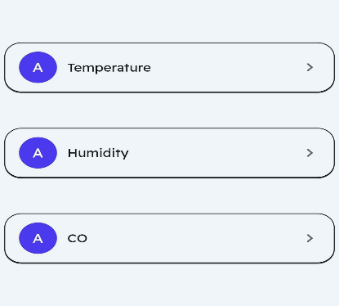
-Next, a template of the forearm was created so that the hardware system
could be built onto it and the patient could use it easily (see fig 10).
Subsequently, the hardware system was linked to a mobile application by Bluetooth and Wi-Fi. The application features icons that enable patients to regulate variables that
Fig (11)
the hardware "sensors" identify, as illustrated in fig (11).

- Test plan:
The test plan called for using Bluetooth and Wi-Fi to transfer the data from the two sensors—the MQ and DHT11—to a mobile application. In order to identify whether the warning is turned on or not. following that, Positive, negative, and observational data were gathered.
- Compiling the code and obtaining data by using an OLED, mobile application, and serial monitor to identify issues.

- After testing the system's response time to input and processing, which was 20 seconds, it was discovered that utilizing an ESP8266 in addition to an Arduino Nano would support the system and speed up processing. This indicates that the "design requirement" was met.

- The system was verified by continuously monitoring the temperature, triggering an alert "flash" when the temperature reaches below15°C or beyond 35°C and when the humidity reaches above 65%.

- Additionally, the smoke from candles, which contains gases (CO& CO2) and particulate matter, was used to test the accuracy of the environment sensing (design requirement achieved) by checking for an increase in smoke percentage to more than 50 ppm.

- Data collection:

The system performed well with the sensors' mutual interference, indicating that the materials chosen for its construction were sound ones.
The smoke produced by lighting the candle is displayed on the OLED in parts per million (ppm) (see table 1).
Table (1) CO2 readings
Test condition | CO2 Level in ppm
Before lighting the candle | 43
After lighting the candle | 281
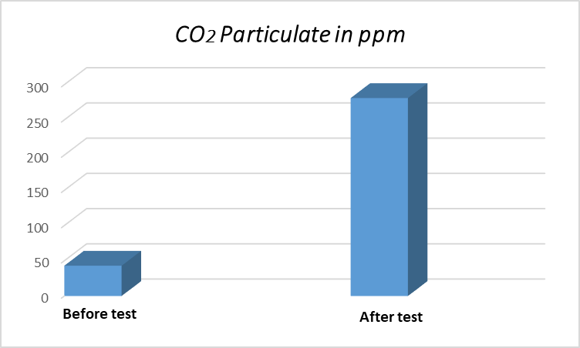

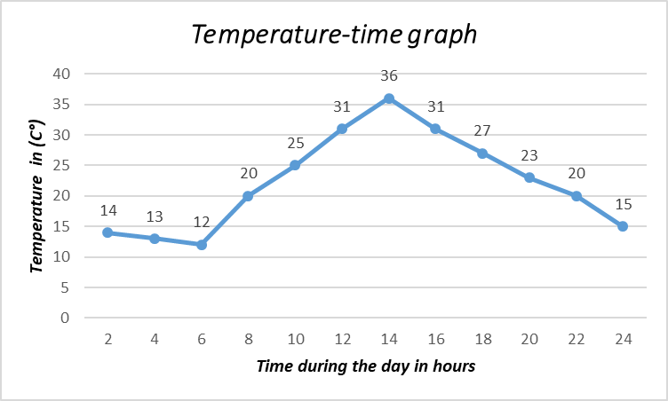
The graph (2) shows the Level of CO2 in the air detected by MQ135

_With respect to time intervals, the temperature changes over the course of a whole day (24 hours) has been recorded by providing the readings on the webpage via ESP8266.

_Two triers have been made with only difference in the option of the icon of temperature trigger condition on the mobile application. With (day one 1 “Hot” icon, day 2” cold” icon).
The graph (3) shows the change in temperature every two hours during day 1

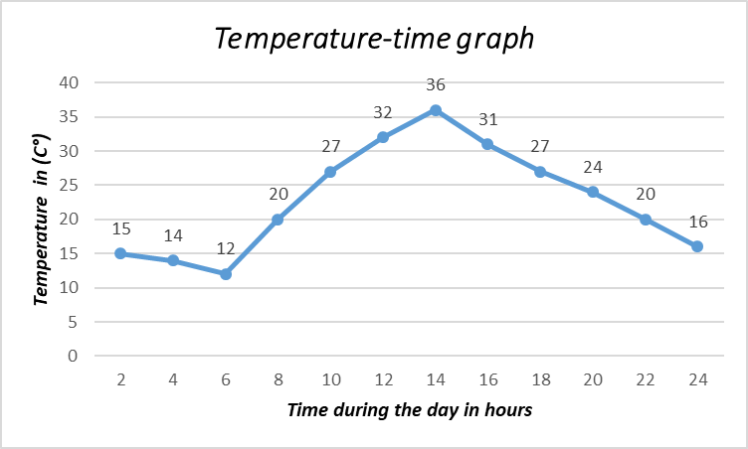

_The change of humidity during a whole day interval have been recorded with the readings of the temperature in day 2

The graph (4) shows the changes in temperature every two hours during day 2

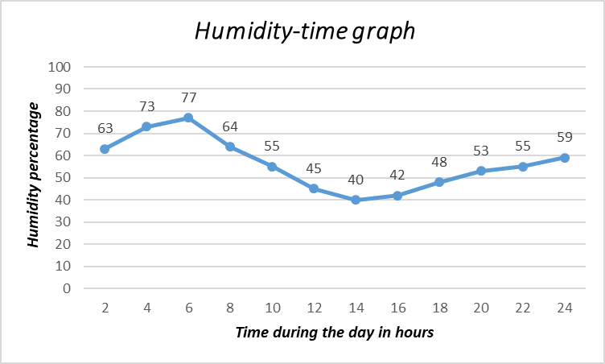

The graph shows how humidity changes u during the day
Table 2: shows the that had only flash turned on one time
in the whole day 1

Time during the day “Hour” | 2 | 4 | 6 | 8 | 10 | 12 | 14 | 16 | 18 | 20 | 22 | 24
Temperature “C°” | 14 | 13 | 12 | 20 | 25 | 31 | 36 ‘’Flash turned on” | 31 | 27 | 23 | 20 | 15

Table 3: shows that the flash had turned on two times in day 2

Time during the day “Hour” | 2 | 4 | 6 | 8 | 10 | 12 | 14 | 16 | 18 | 20 | 22 | 24
Temperature “C°” | 15 | 14‘’Flash turned on” | 12‘’Flash turned on” | 20 | 27 | 32 | 37 | 31 | 27 | 24 | 20 | 16
Table 4: shows that the flash had turned on two times during the early morning

Time during the day “Hour” | 2 | 4 | 6 | 8 | 10 | 12 | 14 | 16 | 18 | 20 | 22 | 24
Humidity percentage (%) | 63 | 73‘’Flash turned on” | 77‘’Flash turned on” | 64 | 55 | 45 | 40 | 42 | 48 | 53 | 55 | 59

Evaluation, Reflection, Recommendations
- Analysis and Discussion:
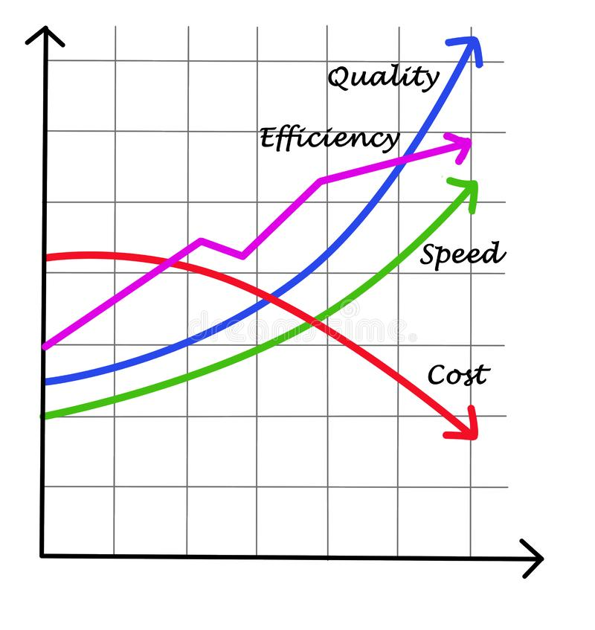
Understanding an issue is the first step towards solving it. The primary goal is to broaden Egypt's industrial base by developing strategies and instruments that enhance public health care and make the lives of individuals with chronic diseases easier. The first step in fixing this kind of issues is identifying its root cause. Given that issues of this nature are global in nature. Resolving these issues would be comparable to finding a hidden gem. Which means that the main goal of all of this is to construct a system that satisfies a set of predetermined constraints.
The Arduino Nano's slower processing speed and inefficiency when handling multiple sensors connected simultaneously caused the project's original results to fall short of expectations. As a result, the plan was changed to utilize the ESP8266 board in conjunction with a DHT11 sensor that was connected via Wi-Fi to a mobile application. To detect smoke particulate, the Nano has merely been attached to the MQ135 device. And the system displays good results in a shorter amount of time after the two boards are connected and the system interferes with a mobile application. which, when the processing system's performance grows, make the project more efficient (see the opposite graph).
The graph (8) represents the elements that affect the efficiency of the project.
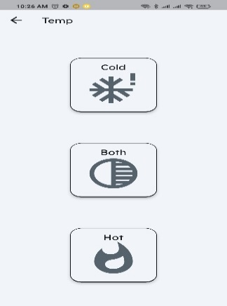
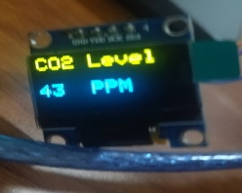
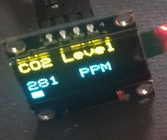
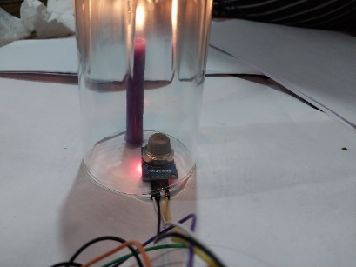
Initially, the Arduino Nano was linked to the MQ135 to detect smoke. This was checked by burning a candle and placing a glass cup over it to make sure smoke didn't escape into the air. To assure safety, the MQ135 was placed with the candle underneath the cup (see figure 12). The desired findings from the sensor are displayed in graph (2). The graph indicates that the sensor measured 43 ppm of CO2 before the candle was even lit. This is because earlier attempts to read the sensor failed due to systematic mistakes in the code, which were fixed with the assistance of Talk GPT (an AI model). And after lighting the candle, there was a noticeable rise in the CO2 level, reaching 281 ppm. The reading on the OLED indicated this change, as shown by the figures (13,14). This data was also sent via the Bluetooth module to the mobile application to warn when the readings surpass 50 ppm, which is what occurred the second the candle was lit; the flash activated as a result of the abrupt change in air quality brought on by the rise in CO2 levels to 281 ppm.
The figure (12) shows DHT11 sense candle’s smoke
Fig (13,14) CO2 readings (smoke)
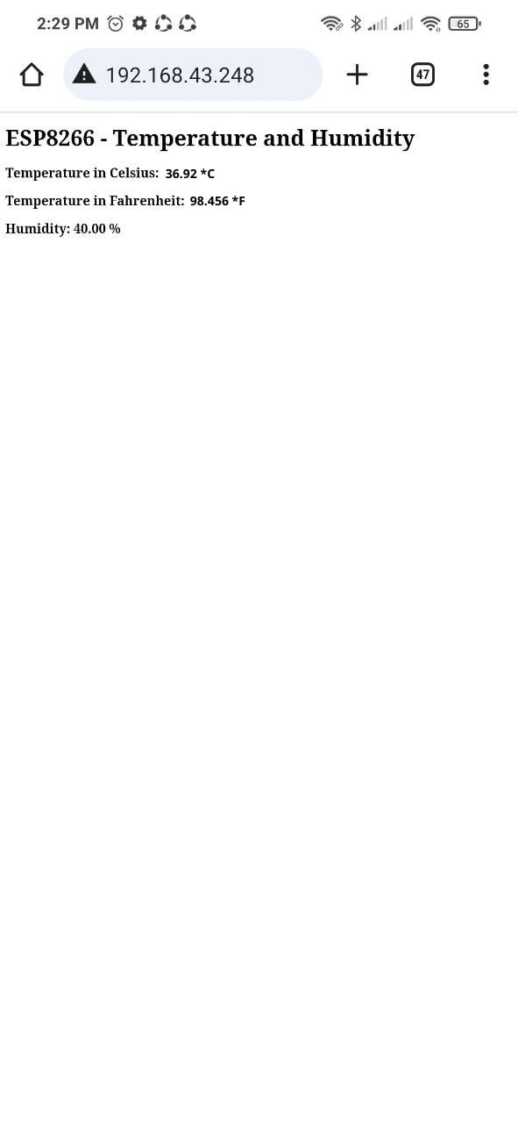
The second factor was to measure the temperature and humidity because these two variables have a significant impact on people with asthma. Some people are affected by increases in temperature, while others are affected by decreases in temperature, and some are even affected by any deviation from the normal range. Additionally, the concentration of water vapor in the air must be taken into consideration, making the temperature and humidity variables both important. Regarding this, the DHT11 sensor was also connected to the Arduino Nano. However, it was later discovered that it is difficult and inefficient to connect the two sensors to the Nano; as a result, the ESP8266 was used to connect to the DHT11, and because of this it was easier to use Wi-Fi via the ESP8266 and retrieve the data via the IP (see fig. 14),Which was connected to the application through Wi-Fi to enable it to take action according to the readings .The temperature readings throughout the course of the two test
Fig (15) Temp and humidity readings via ESP8266 Wi-Fi
Triggers condition due to Temperature in the App
days are displayed on the graph (2,3).
(Table 2) demonstrated that the flash had been triggered at 14:00, which was expected given that this is the time of day when the sun is at its hottest and the mobile application is set to trigger a flash when the temperature rises above 35 C, considering that the hot triggering condition has only been enabled in the mobile application. In contrast to the events of day one, (Table 3) shows day two the flash was activated to draw attention only when the temperature dropped below 15 degrees Celsius between 4 and 6 in the morning. And the reason for this is that the "cold" icon trigger condition had been triggered, which was predicted because the lowest temperatures often occur right before sunrise. (The application's figure illustrates the condition).
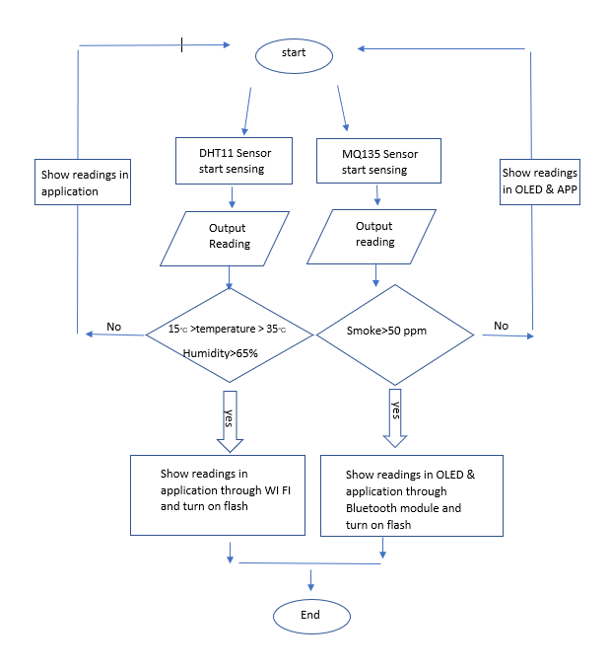
Because of the high concentration of water vapor in the morning, the result of the humidity during the day demonstrates its inverse relationship to the temperature. This highlights the importance of monitoring humidity levels throughout the day because it directly affects asthma patients and can be predicted based on the relationship between temperature and humidity. The peak of humidity occurs at 6 am, when the temperature is at its lowest. (see graph 5).
_ (Figure 16) clearly illustrates the building of the communication system, and the flow map on the other side provides a summary of the preceding process's analysis and procedure.
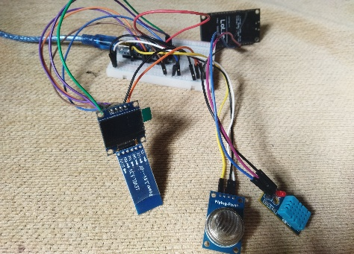
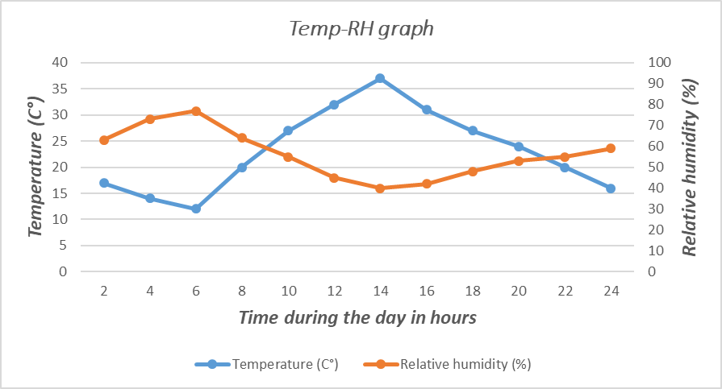

The figure (16) shows the components of the prototype
The graph (5) shows the inverse relationship between Temp and relative humidity.

Many laws and principles were used to build the system and accomplish all wanted design requirements.
Here are some main reasons why the candle’s smoke has been chosen to make test on:
1-Particulate Matter: Burning a candle produces tiny particles, often referred to as particulate matter. This can include both visible soot particles and invisible particles like PM2.5 (particles with a diameter of 2.5 micrometers or smaller).
2-Water Vapor: As the wax combusts, it reacts with oxygen to produce carbon dioxide (CO2) and water vapor (H2O).
_A statistical measurement of the strength of a linear relationship between two variables called the correlation coefficient has been used to calculate the relation between the temperature and humidity through this law:
r= Cov (H, T)/SDH*SDT
= n*∑xy - ∑x^2 * ∑y^2 / √((n*∑x^2)- ∑(x)^2) *((n*∑y^2)- ∑(y)^2)
n=3
∑x=24+20+16=60
∑y=53+55+59=167
∑xy= (24×53) +(20×55) +(16×59) =3316
∑x2= (24²) +(20²) +(16²) =1232
∑y2= (53²) +(55²) +(59²) =9315
By substitution r = -0,981
Therefore, the correlation coefficient for this pair of data is -0.981, indicating a strong negative correlation between temperature and humidity.
- Recommendation:
The following suggestions are for anyone wishing to enhance this project or for future work on it:
1. Considering other asthmatic triggers, such as pollen or air pollution, in order to improve asthma patients' quality of life and make life easier for them. This would increase the efficacy of treating asthma symptoms.
2. The accuracy of identifying environmental triggers for asthma patients is increased when a dedicated smoke sensor is used in place of the MQ135 for smoke.
3. Expanding the functionality of the mobile application Working together with medical professionals: In order to enable medical personnel to give their asthmatic patients better individualized and knowledgeable care, think about creating a framework that would allow them to access and examine the data gathered by the system.
4. Including an icon for input from medical professionals and asthma patients to better understand their individual requirements and preferences for asthma management within the system.
All things considered, it is advised to put our proposal into action since it satisfies numerous design criteria that show its efficacy and quick processing and response time in comparison to most IoT communication systems.
For who want to start where we stopped:
Use accuracy of identifying environmental triggers for asthma patients is increased when a dedicated smoke sensor is used in place of the MQ135 for smoke.

- Learning Outcomes:

Subject | Number of learning outcome | Connection
Chemistry | L.O1 | -it helped us about different types of analysis: quantitative & qualitative analysis, so we use them in our project to ensure its effectiveness and meet our design requirements.
Physics | L.O1 | - In ITC, sensors are widely used to measure physical quantities and collect data. Simple harmonic motion be measured and analyzed using sensors such as accelerometers, displacement sensors, or strain gauges. This data processed and analyzed using ITC techniques to obtain valuable insights or control systems.
Biology | L.O1 | -Cell body (soma) of a neuron is the center of integrating information similar to the Arduino board; dendrites are responsible for receiving stimulus similar to sensors that detect certain external factors; axons are like wires that transmit the electrical signals through the neuron.
Biology | L.O1 | - Mechanisms of synaptic communication, helped us that we develop a better understanding of how environment affects the asthma patient and how to manage it effectively. This knowledge informs the development of personalized recommendations and alerts provided by Project Asthma's mobile application, which help patients manage their condition more effectively
Chemistry | L.O1 | - it helped us understand the sources of uncertainty in our measurements and how to minimize them. In our project, uncertainty occur due to systematic errors such as those caused by the sensor used or coding mistakes. To avoid these errors, we evaluate the accuracy of the sensor by comparing its measurements with those obtained from other measuring devices.
Geology | L.O2 | - it helped us used to track the movement patterns of individuals with asthma and identify potential triggers for asthma attacks. By analyzing the data collected, so we identify environmental factors such as pollution levels and other allergens that may trigger asthma symptoms.
English | Unit 1 new hello | -it helped us about piracy of books and articles, so we make sure to obtain our research resources in a legal way and not copy or cheat others.
English | Unit 4 new hello | -it helped us about how to avoid burnouts by taking care of our physical and mental health. This demonstrate the importance of well-being and helping people with chronic disorders and physical disabilities.
Physics | L.O4 | - is relevant to the Project Asthma because it helped us understand the technology behind wireless communication, which is used by the mobile application to receive information from the sensor. The transducer in this case is the sensor, which converts mechanical signals from the environment into electrical signals. These signals are then transmitted wirelessly through Wi-Fi or Bluetooth, which use electromagnetic waves as the medium. The receiver is the mobile application, which receives the electrical signals and converts them back into information that can be used to monitor and manage asthma symptoms.
Biology | L.O2 | -The CNS, consisting of the brain and spinal cord, is responsible for processing the signals received from the sensors and generating appropriate responses. The ANS, specifically the parasympathetic and sympathetic divisions, regulates various bodily functions, including heart rate, blood pressure, and stress responses which all relate to the causes of various chronic disorders.

APA:
Urry, L. A., Cain, M. L. 1., Wasserman, S. A., Minorsky, P. V., Reece, J. B., & Campbell, N. A. (2017). Campbell biology. Eleventh edition. New York, NY, Pearson Education, Inc.
Halliday, D. (2004). Physics. Wiley Custom Services.
staff, M. c. (2022, March 5). asthma. Retrieved october 29, 2023, from Mayo Clinic: https://www.mayoclinic.org/diseases-conditions/asthma/diagnosis-treatment/drc-20369660
Yusni, A. (2023, May 2). 5 ways to keep your asthma under control. Retrieved from WHO: https://www.who.int/news-room/feature-stories/detail/dont-let-asthma-hold-you-back-5-ways-to-make-sure-that-you-are-in-control-of-your-asthma
Asthma Symptoms. (2023, january 26). Retrieved from Asthma & Allergy Foundation of America: https://aafa.org/asthma/asthma-symptoms/
DHT11 Sensor Definition, Working and Applications. (2019, August 6). Retrieved November 16, 2023, from ElProCus: https://www.elprocus.com/a-brief-on-dht11-sensor/
Heinecke, R. (2020, April 7). Air Quality Sensor. Retrieved from Breeze Technologies: https://www.breeze-technologies.de/air-quality-sensors/
Asthma and Allergy Foundation of America. "Weather Triggers: Asthma." AAFA, www.aafa.org/asthma/asthma-triggers-causes/weather-triggers-asthma/. Accessed 10 Nov. 2021
"AllThingsTalk - How does humidity and temperature ratio relate to your health?" AllThingsTalk, www.allthingstalk.com/faq/how-does-humidity-and-temperature-ratio-relate-to-your-health. Accessed 10 Nov.
Installing Libraries. (n.d.). Retrieved November 20, 2023, from Arduino Documentation: https://docs.arduino.cc/software/ide-v1/tutorials/installing-libraries

